***All purchases now go through the Shopping Cart once debit functionality is enabled on your self-service terminal***
- Must tape packs together if loading multiple packs in a bin since players can add the tickets more than are available if they do not see the low inventory count on the game icon due to packs are not taped together

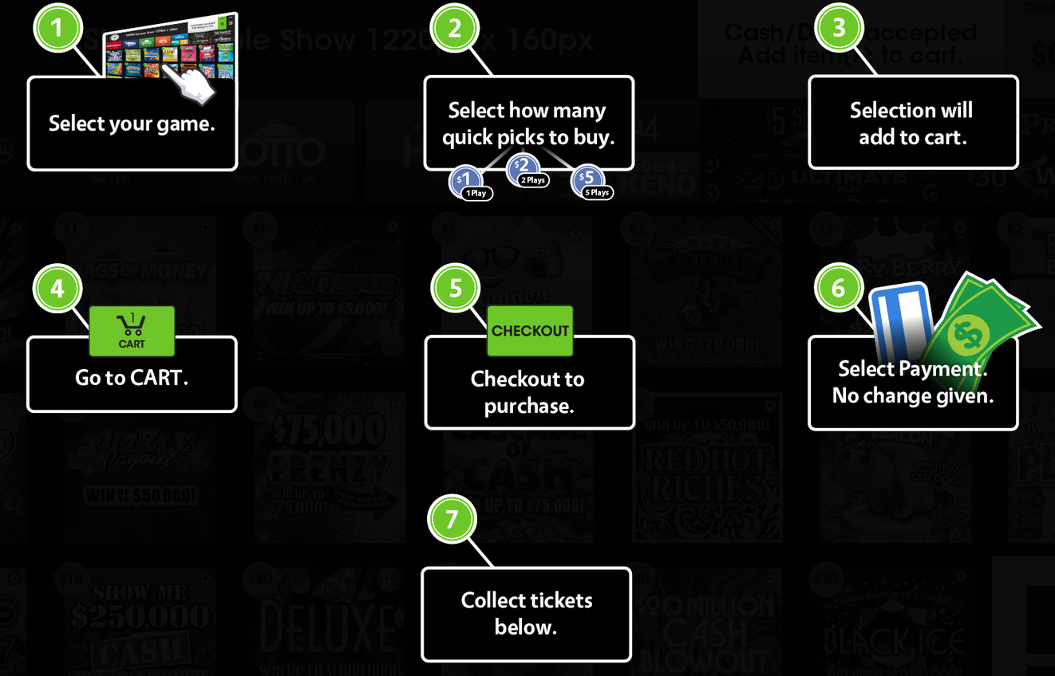

Cash, winnings, or debit card payment can be made after the completion of the shopping cart session on the touchscreen of the Lottery vending machine.
- Credit card, tap pay, or any mobile pay options are not available at this time
- Cannot combine a partial cash winnings with a debit payment
- All shopping carts are required to be paid with either cash, winnings, or debit (not a combination of both)
- Debit payment option will be disabled if cash is inserted first before selecting tickets for the shopping cart
  - Debit payment option is not available during the terminal maintenance window time (midnight to 12:30am) nightly
- After 60 seconds, an idle shopping cart will be emptied and have to start over building the shopping cart
- When using Debit, their billing Zip code will be the verification used
  - Some cards will require to enter both Zip code and the PIN
- There is a $700 7-day spending limit for a debit card used
  - There is still a single transaction limit of $500
- Receipts for completed purchases are not provided
- Debit transactions are shown by the number of transactions and dollar value total on both Daily Sales Activity Report and Shift Report

  - A receipt will automatically print if there is an error with debit transaction when dispensing tickets
    - Do not give the player a cash refund related to Debit transactions
  - The receipt will show the total amount of debit spent
  - The cash log will be used just to verify transactions. If a player asked what their refund would be, the store could look at the cash log and see the amount
  - Players will Automatically (within 10 business days) be credited to unused balance if error occurs. Players may call 1-800-545-7510
  - Example in red is a debit card transaction total and example in green is debit card transaction refund
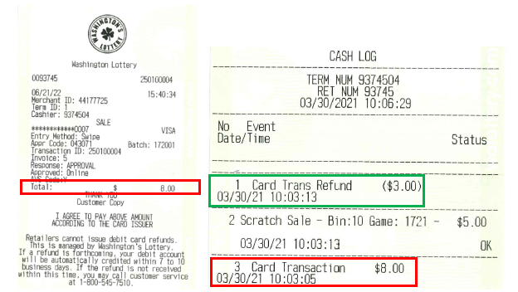
- How to run a Cash Log
  - Select Logging / Security and then Select Cash Log
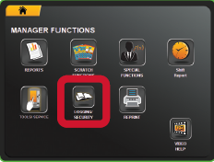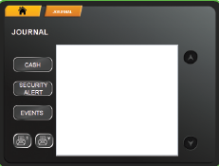
In the event of a printer jam or a ticket stuck in a burster without issuing refund for player (cash or debit transaction)
Scratch Ticket did not dispense
- Remove the ticket from the burster
- Give the ticket to the player
- Clear and reload the inventory by scanning first and last ticket
Draw Game Ticket did not dispense
- Run Cash Log and verify the transaction with an error
- Refund player for the jammed ticket
- Contact your DSR to pick up the jammed ticket for credit request

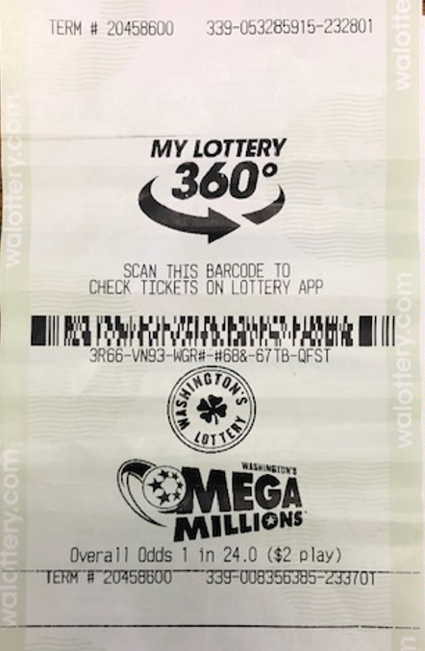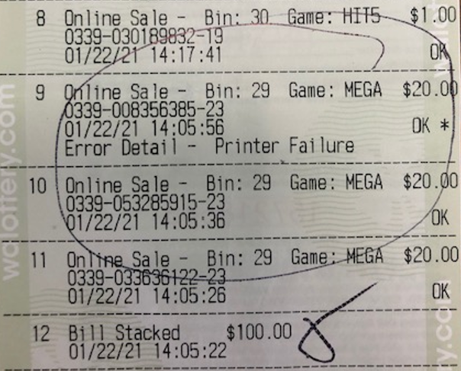

- How to reprint a receipt
- The receipt can be reprinted using the Last Transaction from the REPRINT in the event of printer jam
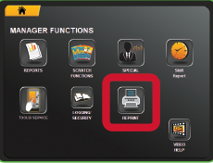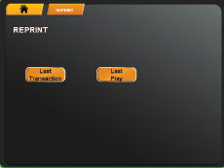

To begin transaction with the Lottery vending machine with Shopping Cart feature
- Touch screen to activate
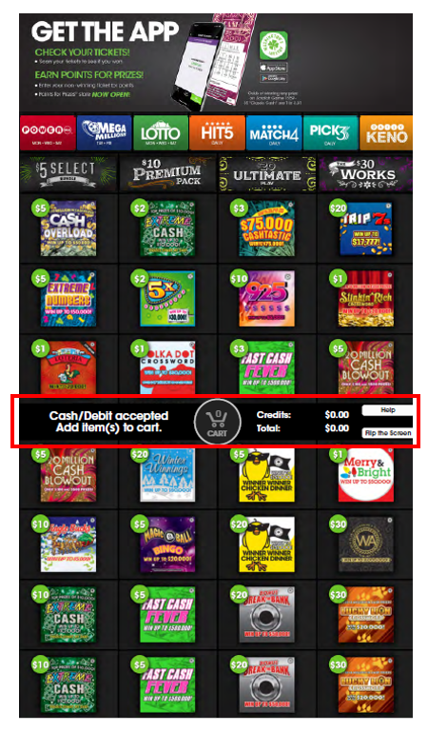
- Make selections for draw games or/and scratch games to build your shopping cart
- Continue shopping or select Cart to checkout
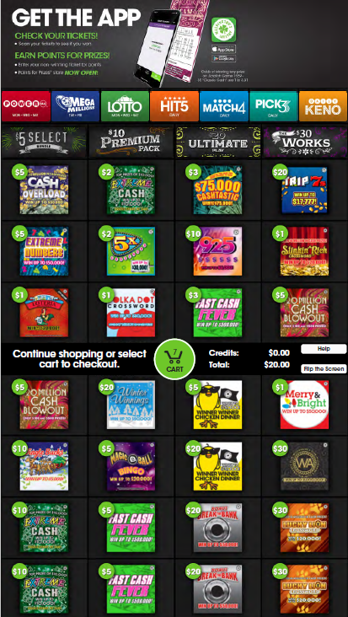
- Continue shopping or select Checkout to purchase
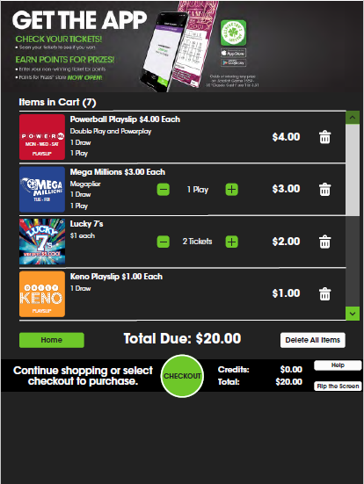
- Select a payment method
  - Pay with Cash, Winnings OR Pay with Debit

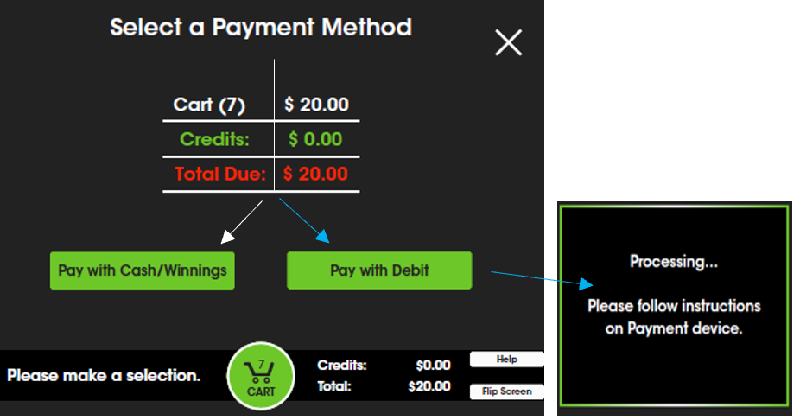

- If paying with Debit, follow instructions on the Verifone card reader, located on the right side of the SST
- After a 3-7 seconds initialization period, the card reader will prompt the customer to insert their card before completing the transaction, and tickets are dispensed
  - When the Verifone card reader is ready, complete transaction by going to payment device located at right of vending machine
  - Insert (or swipe) the debit card
  - Follow Zip code prompts

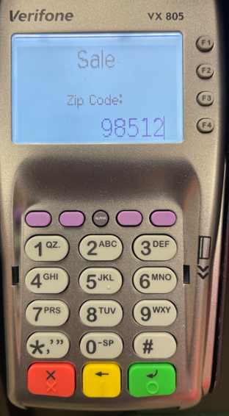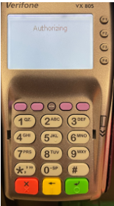

- The card reader will complete processing the transaction and tickets will be dispensed

GT1200 Terminal (Terminal at the counter)
There are two Daily Sales Reports which should be used for cash accounting for your GT1200 terminal at the counter if you have a Lottery vending machine.
- Daily Sales Activity Report (Reports>General Reports>Daily Sales Activity)
- This is date specific, and the amount is accumulated throughout the day.
- Both terminals (GT1200 & Lottery Vending Machine) sales and payouts will be included on report
- Most current will be from this morning’s sign-on until now
- Two Separate payout total; Draw and Scratch
- Does not track the individual scratch ticket sales
  - Enter the desired date and press SEND
  - Can be printed for up to 180 days back

- Daily Term Activity Report (Reports>Lotto To Go Reports>Daily Term Activity)
- Separate reports can be printed for each terminal, GT1200 (Your retailer number plus 00) or Lottery Vending Machines (Your retailer number plus 01, 02, or 03 etc.)
  - Enter the desired date
  - Enter the terminal ID number
  - Can be printed for up to 180 days back

Both Terminals (GT1200 + Gemini Touch) GT1200 Terminal Only
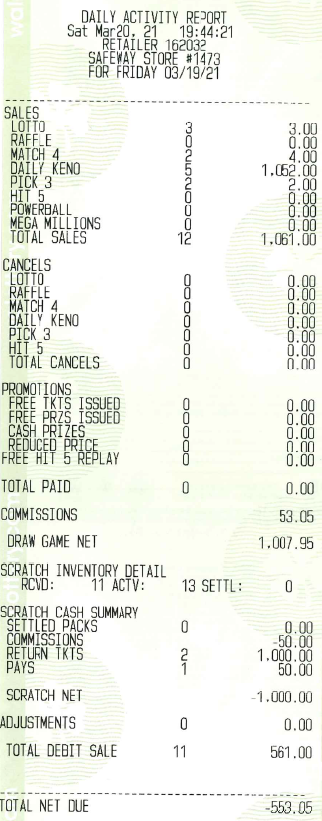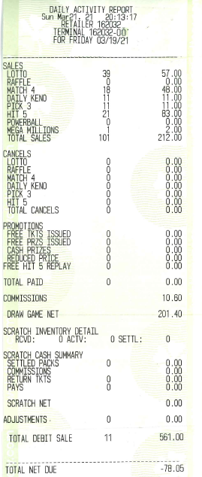
Terminal ID Numbers: For Sign on and report purposes know your terminal ID number!
- GT1200 Lottery terminal= Retailer Number + 00

- Lottery Vending Machine= Retailer Number + 01 (02, 03 and so on if you have multiple Lottery Vending machines)
  - There are some terminals are exceptional to this rule and the terminal ID can be found on any sales reports from the Lottery Vending Machine

***Note***
A line is added for Debit Card transaction on all reports. This total includes both Scratch and Draw Debit transactions.

Gemini Touch Terminal (Lottery Vending Machine)
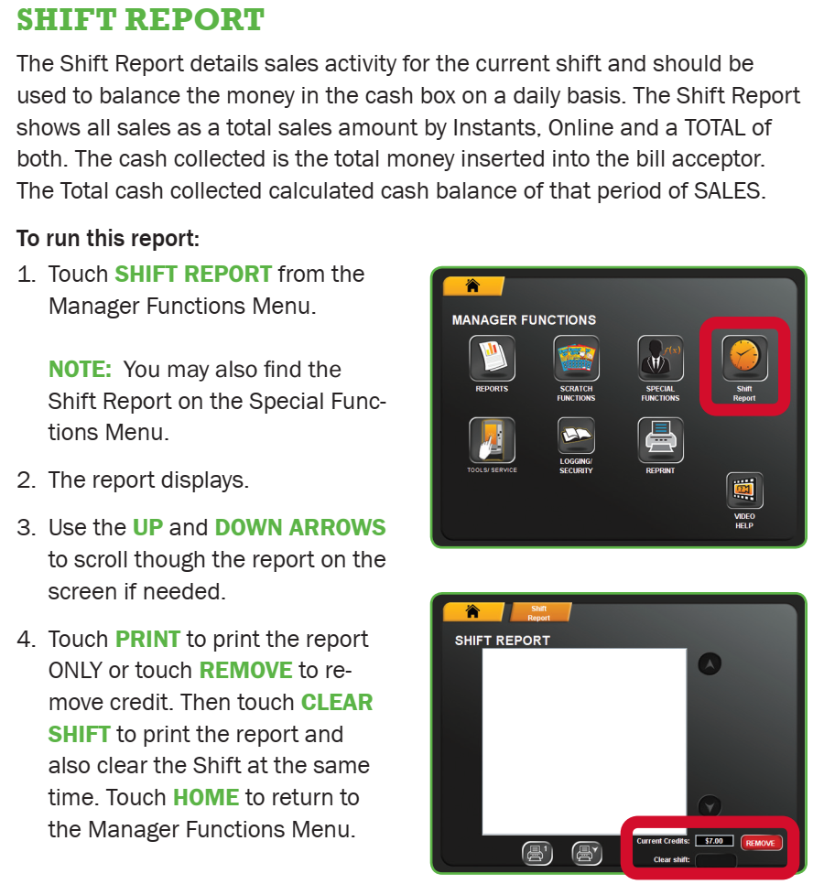

How To Reconcile the Cash Accounting for Lottery Vending Machine
Lottery retailers must remove the cash from their Lottery vending machine within 21 days of when the cash box is full. It is common for Lottery retailers to remove their cash once a week, or once a day but it is your choice.
There is one report that provides all accounting information needed to reconcile the cash, the Shift Report. The Shift Report tracks sales by Bin/Game, Reinvestment, Debit transactions, any refunds issued, and will maintain a bill count by denominations. If used correctly the report will track the start and end for a given accounting period (see example below).
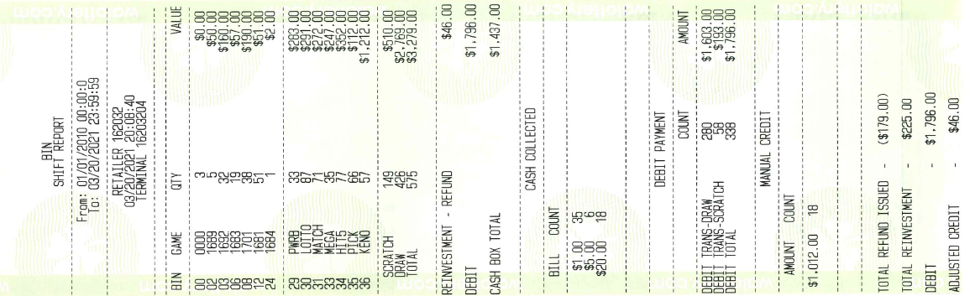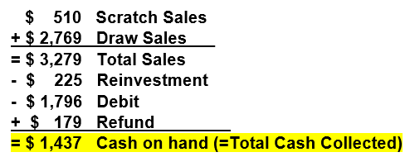
Reinvestments are generated when customers elect to redeem their winning tickets for additional credit towards tickets purchase with a maximum of $500 per transaction

